[Test Plan] belajar bareng version 1.0

Document Status | [DRAFT] [REVIEWED] [FINAL]
Test Plan Creator | Paula Carnelian T
Test Plan Reviewer | - Rafis  - Siti  - Reviewer_3

Introduction

Overview Feature to be tested
This Test Plan is made to ensure that all features on the http://belajar-bareng.onrender.com website function properly and meet the criteria according to user needs.

Goals and Objective
The http://belajar-bareng.onrender.com website is a web-based user management system that allows users to perform CRUD (Create, Read, Update, Delete) operations.

The system provides features such as login, viewing user list, adding new users, updating user data, and deleting users. These features are supported by API endpoints such as POST (login, add user), GET (list users), PUT (update user), and DELETE (delete user).

The testing process will be conducted using manual testing to ensure that all functionalities work correctly and meet user requirements. The testing scenarios include validating input fields, verifying CRUD operations, and ensuring that system responses are accurate for both valid and invalid conditions.

Test Item
List of test items (feature / product)

No | Feature | Test Item
#1 | Sign in | 1. Sign in with valid credentials  2. Sign in with invalid credentials  3. Sign in with user doesn’t exist  4. Sign in with empty fields
#2 | List Users | 1. Display list of users  2. Show correct user data (name, age, ID)
#3 | Add Users | 1. Add user with valid data  2. Add user with empty input  3. Add user with invalid data (e.g age text)
#4 | Update User | 1.Select users from drop down  2. Update user with valid data  3. Update user with empty fields
#5 | Delete Users | 1. Delete selected user  2. Validate user is removed from list
#6 | Navigation | 1. Navigate between pages (List, Add, Update)  2. Button functions properly
#7 | Checkout | 1. Click checkout button  2. Verify system response after clicking

In Scope Testing
List of in feature to be tested

No | Feature | Requirement / Design specifications
#1 | Sign in | 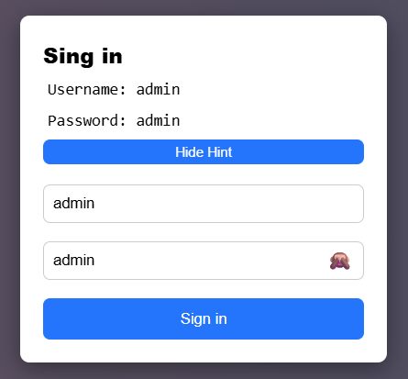
#2 | Add Users | 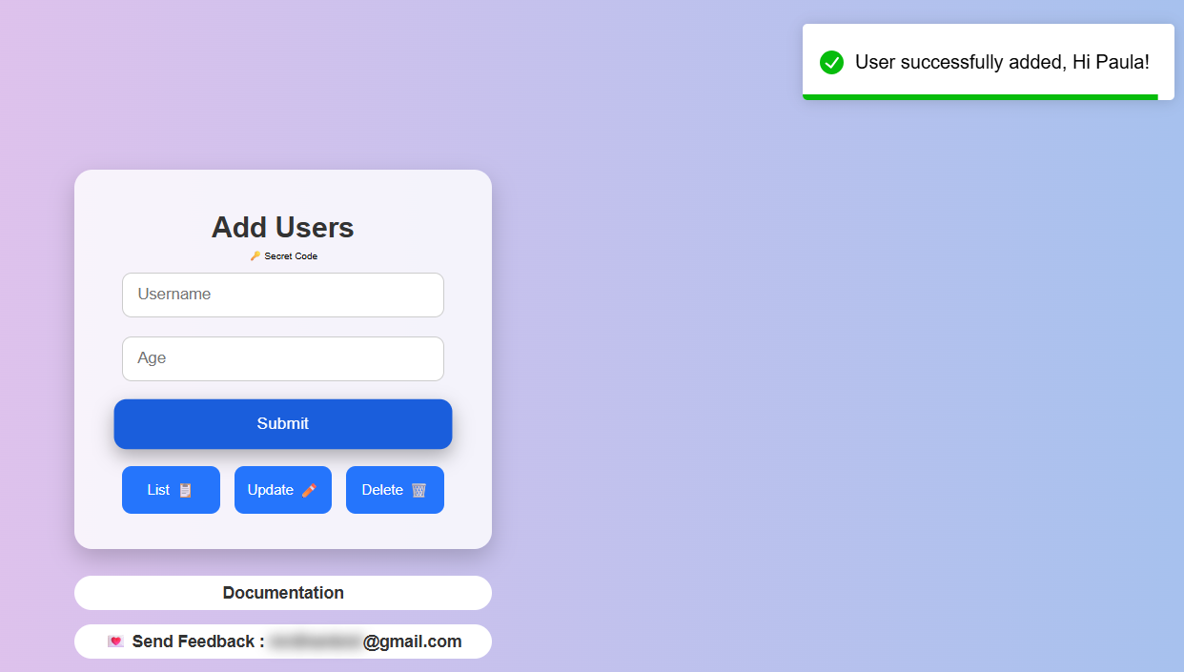
#3 | Update User | 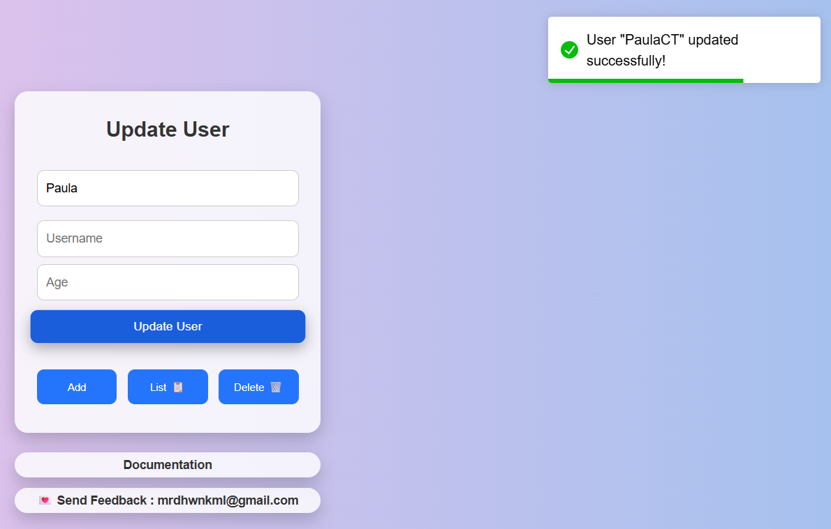
#5 | Delete User | 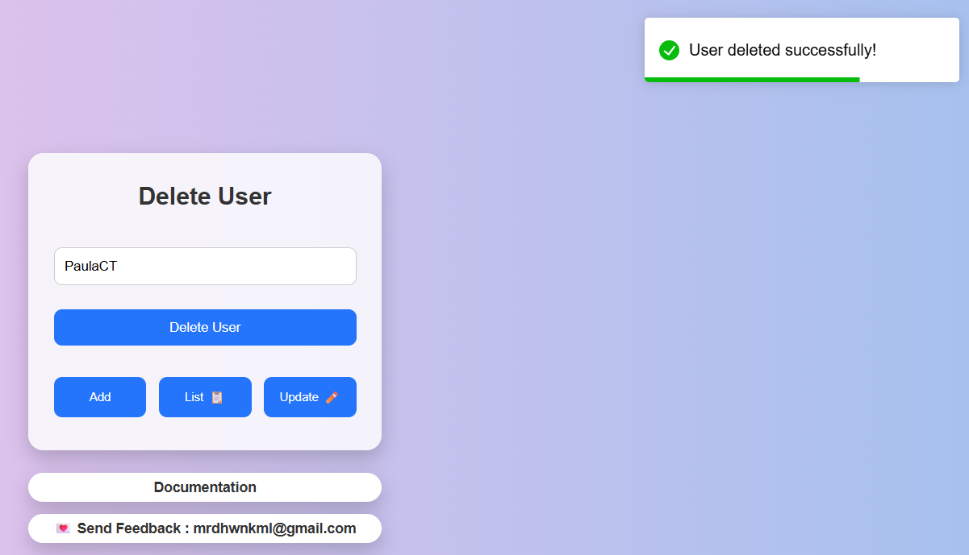
#6 | Checkout | 

Out of Scope Testing
List the features of the software / product which will not be tested.

No | Feature | Reasons
#1 | Logout | Feature not available in system
#2 | Performance Testing | Not included in the testing phase
#3 | Security Testing | Requires advanced tools
#4 | API Deep Testing | Only basic validation via UI is performed
#5 | Documentation | Only for reference,not tested

Testing Approach
Summary of testing approach that will be implemented during testing phase

The testing approach used in this project is manual testing with a black-box testing method, where the tester focuses on validating system functionality without accessing the internal code.

Exploratory testing is applied to understand the system behavior by interacting directly with the http://belajar-bareng.onrender.com website. The tester explores all available features such as login, user management (CRUD), navigation, and checkout.

Both positive and negative test scenarios are executed to ensure that the system can handle valid and invalid inputs properly. The testing also includes basic validation of API behavior through UI interaction, ensuring that all CRUD operations reflect correctly on the interface.

The testing process uses Exploratory testing type because the tester does not know from the beginning the process of making the http://belajar-bareng.onrender.com website. So that the tester explores the website to test whether the website is suitable and can be used by users without any problems.

Test Environment
Information about testing environment that will be used during testing phase e.g URL, and version of App
- Website: http://belajar-bareng.onrender.com
- Env: Production
- Browser: Edge, Chrome, Firefox
- Operating System: Windows 10 / 11
- Device: Laptop / Desktop

Test Deliverables
- Test Plan: this document
- Test Case: Document containing detailed test scenarios
- Test Script: Not available (manual testing)
- Test data: Dummy data used for testing (e.g name, age)
- Defect Report: Document containing identified bugs
- Test Report: Summary of testing results

Testing Timeline

No | Task | Estimation Time |  | Actual Time
 |  | Start Date | Finish Date | Start Date | Finish Date
#1 | Develop Test Planning | 6 April 2026 | 7 April 2026 | 6 April 2026 | 6 April 2026
#2 | Develop Test Case | 6 April 2026 | 7 April 2026 | 6 April 2026 | 6 April 2026
#3 | Test Case Review | 6 April 2026 | 7 April 2026 | 6 April 2026 | 6 April 2026
#4 | Execute Test | 7 April 2026 | 8 April 2026 | 7 April 2026 | 7 April 2026
#5 | Retest Bug | 7 April 2026 | 8 April 2026 | 7 April 2026 | 7 April 2026

References
List of related documents e.g PRD, Figma design, API Contract, Copy document etc

Website: http://belajar-bareng.onrender.com

API Documentation: Available on the Documentation page within the website

No additional documents provided

